Wolf Peach Farms

Table of Contents

General Tomato Info
- Botany Basics………………………………………….…………………………………………………………...…..1
- Growth Stages of Tomato Plant…………………………...…………………………………………………….6
- How to Prune Tomatoes……………………………………………………………………………………………7
- Disease, Pests, and Deficiencies…………………………………………..…………….………………………9

Hydroponics System Setup
- Water Cycle and Storage…………………………………………………….…………………………………...13
- Nutrient Solution…………………………………………………………………………………..………………..15
- Air Quality Control……………………………………………………….……………………….………………..17
- Electrical and Lighting………………………………………………………………..…………………………..19
- Cleaning and Sterilization…………………………………………….........……………………………………20
- Growing Method and Plant Care………………………….……………………………..……………………21

Why We Grow
- Grow Plan…………………………………………………………….
- Numbers and Relationships…………………………………………………………
- Investigational Studies………………………………………………

Daily Logs

Maintenance Logs

Nutrient Reservoir Logs

Appendix
- Target Values…………………………………………………………………………………………………………23
- Nutrition Plan………………………………………………………………………………………………………...24
- Nutrient Deficiency Symptoms………………………………………………………………………………..25
- Equipment Information…………………………………………………………………………………………..29
- CO2 Distribution……………………………...……………………………………………………………………..30
- CMH vs. LED……………………………………………………………………………………...……………………31
- Conversions and Numbers………………………………………………………………………………………33

Table of Figures
Figure 1: Visual demonstration of osmosis. 3
Figure 2: Guard cells of the stomata (left). Water and oxygen leave stomata as CO2 enters (right). 3
Figure 3: Reproductive organs of tomato flower. 4
Figure 4: Growth stages of tomato plant. 5
Figure 5: Examples of suckers on tomato plants. 6
Figure 6: Visual symptoms of nutrient deficiencies. 23
Figure 7: Plant nutrient deficiencies chart. 24
Figure 8: CO2 timing chart. 28
Figure 9: Optic 4 LED spectrum. 30
Figure 10: General CMH fixture spectrum, McCree Curve shown in black. 30
Figure 11: Spectrum of natural sunlight. 30
List of Tables
Table 1: Optimal Conditions for Nutrient Solution 21
Table 2: Evaluation of pH Values for Plant Growth 21
Table 3: Optimal Atmospheric Conditions 21
Table 4: Advanced Nutrients' Diet Recommendation (mL/L of water) 22
Table 5: Estimated Solution Volume Usage 22
Table 6: Equipment Power Source Allocation 27
Table 7: Equipment Schedule 27

Chapter 1
General Tomato Info

Botany Basics
Photosynthesis
Photosynthesis is the process used by plants to produce simple sugars or carbohydrates which it then uses for food/energy. Carbon dioxide (CO₂) from the air combines with water (H₂O) under the influence of chlorophyll to produce simple sugars (glucose, C₆H₁₂O₆) and oxygen (O₂). This is represented by the chemical equation below:
6CO₂ + 6H₂O + Light → C₆H₁₂O₆ + 6O₂ (Photosynthesis)
C₆H₁₂O₆ + 6O₂ → 6CO₂ + 6H₂O + Energy (Respiration)
Chlorophyll is present in the chloroplasts in the leaves and stems of plants. It is responsible for the green color of the leaves as it reflects green light. This indicates that the green portion of the light spectrum does not contribute much to photosynthesis. The blue and red portions of the spectrum contribute the most. Blue is used more in vegetation and red more in fruiting and flowering.
The purpose of chlorophyll is to absorb the energy from light and transfer it to the rest of the photosystem which then uses that energy to turn the CO₂ into sugars. The sugars produced are used to manufacture all of the other molecules needed for life (simple and complex carbohydrates, proteins, and fats). Some are metabolized right away while some are stored in starches and saved to metabolize at night when photosynthesis stops. Water is required in turning the CO₂ into sugars. The splitting of water produces oxygen, which is then released in transpiration through the stomata.
Respiration
Respiration is the opposite of photosynthesis and is referred to as a plant’s method of breathing. Plants take up O₂ through their roots and use it to break down the sugars created by photosynthesis, which results in the release of CO₂ and water vapor. The major product of respiration is energy in the form of ATP (referred to as the cellular energy currency), which is sent all over the plant to carry out all sorts of tasks. The equation above doesn’t represent the entire process, as ATP production is much more complex, but it shows how plants convert their sugars into usable energy and the products and reagents required to do so.
Respiration takes place at a much slower rate than photosynthesis, so plants release much more O₂ than they do CO₂. However, respiration doesn’t require light like photosynthesis, so it occurs during the day and night. This is why the CO₂ supply in grow rooms should be shutoff at night because the plants are releasing their own CO₂ and won’t consume any until the lights come back on and they begin to photosynthesize again.
The sugars plants respire at night are the ones that were stored as starches during photosynthesis. With its own internal biological clock, the plant is able to sense the length of the night and adjust its rate of respiration so only a little bit of starch is left at dawn. If the length of the night remains constant, then the rate of respiration during the day is equal to the rate at night.
Plants often desire cooler temperatures at night to help cool them off. Without photosynthesis there is much less evaporative cooling going on, so the plants need a little extra help. This happens naturally outdoors when the sun goes down, and plants evolved to learn to take advantage of the temperature drop. This is why it is important to supply the temperature drop for the plants in a grow room.
Transpiration
Transpiration refers to the evaporation of water from plants. It occurs mainly at the leaves while the stomata are open for the passage of CO₂ and O₂ during photosynthesis. Air that is not fully saturated with water vapor (100% humidity) will cause drying of the cell surfaces with which it is in contact. Transpiration provides many benefits for the plant: it plays a role in photosynthesis, draws water and minerals up from the roots, and helps cool down the plant. That being said, too much transpiration leads to more water loss from the plant.
The rate of transpiration is affected by the following factors:
Light – light stimulates the stomata to open and warms the plants, both of which increase the rate of transpiration.
Temperature – water evaporates more readily at higher temperatures and warmer air has greater capacity to hold more water vapor. A leaf may transpire three times faster at 86°F than 68°F.
Humidity – lower humidity increases the rate at which water evaporates
Wind – with no breeze, the air surrounding the leaf becomes more humid as the plant transpires and the rate of transpiration will decrease, however a breeze will move this air and replace it with drier air causing the plant to transpire even more
Soil Water – a plant will not continue to transpire if the transpired water is not replaced by water from the roots. When the water is not replaced, the plant loses turgor pressure (cellular water pressure) causing the stomata to close. This also reduces production from photosynthesis. If the loss of turgor pressure spreads through the leaf to the stem, the plant will begin to wilt.
Osmosis
Osmosis is the spontaneous movement of water through a semipermeable membrane, moving from a lower salt concentration to a higher salt concentration; if the concentrations are equal, osmosis does not occur. Osmosis is responsible for almost all of the water movement in plants and is necessary to keep a healthy turgor pressure inside the plant. In plants, fluids are pulled through xylem/phloem (similar to veins) unlike animals where they pushed (i.e. blood) through veins.
When water is drawn through osmosis, water-soluble salts move with it. This is how nutrients are absorbed from the soil and dispersed across the plant. If the concentration of salts in the soil is less than that in the plant roots, the roots absorb the water along with the dissolved nutrients. However, if the concentration of salts in the soil is higher than that of the roots, then water is sucked out of the roots and into the soil, burning the roots and eventually killing the plant.
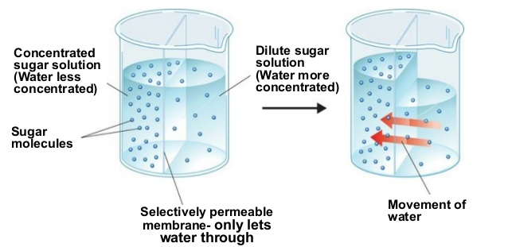

Figure 1: Visual demonstration of osmosis.
Stomata
Stomata are pores in the protective cuticle on the underside of leaves. The main organelles are the stoma’s two guard cells; they are the door/window into the leaf. Stomata play a large role in both photosynthesis and transpiration.
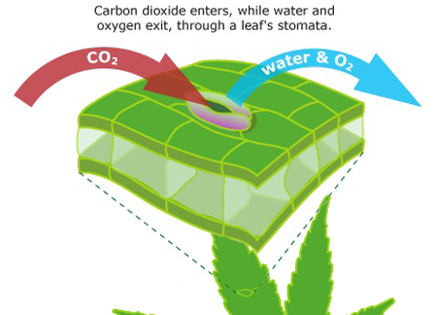
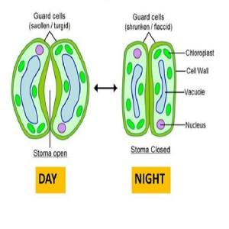

Figure 2: Guard cells of the stomata (left). Water and oxygen leave stomata as CO2 enters (right).
In photosynthesis, the presence of light triggers stomata to open, allowing carbon dioxide to flow in and oxygen to flow out. Stomata respond to low CO₂ levels by opening so they can gather more of it. Contrarily the stomata close if the carbon dioxide concentrations in the atmosphere are increased. This is good as it will conserve water, however it could also suffocate and overheat the plants as they are not allowed to transpire and cool themselves off as much. Therefore CO₂ PPM levels in the grow room must be monitored and kept at a target value of 1200 PPM (1500 PPM max).
The action of the stomata is what makes humidity so important. With higher humidity, water vapor escapes at a slower rate through the stomata as the surrounding air is more saturated with vapor. This allows the plant to hold on to more of its water. However higher humidity increases the threat of fungal attack, so humidity control and good airflow are essential to maintain.
Pollination/Fruiting
Tomatoes are self-pollinating in that each flower has both the male and female parts that are needed to fertilize the plant. Once fertilized, the flower will produce fruit. Even though the plant carries both parts and is considered “self-pollinating”, it still needs help getting fertilized.
Stamen – the male part which surrounds the pistil and is comprised of anther and filament
Anther – the pollen of the flower is located in these
Pistil – the female part made up of the style and stigma, located in the center of the flower
Style – the long stalk extending from the ovary to the stigma
Stigma – the bumpy and sticky site that accepts the pollen for pollination
Ovules – the part of the flower that gets fertilized to form a seed
Ovaries – the part of the flower that houses the ovules
As mentioned above, the blossoms are said to be self-fertile, but there is no fruit formation if the pollen does not move from anther to stigma. In nature, the vibration from bees’ wings causes the whole flower to vibrate and release a cloud of pollen inside the stamen. Because the blossoms normally hang downward, the pollen drops down through the stamen and falls on the stigma, and pollination occurs. The pollen then grows down the style until it reaches the ovary and fertilizes the ovule to form a seed.
In the absence of bees, tomato flowers are typically wind pollinated or fail to pollinate and drop off. For this reason, flowers must be hand pollinated in the grow room to ensure fertilization (see section 2.6 Growing Method and Plant Care).
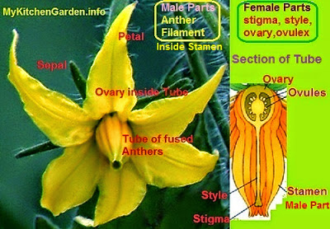

Figure 3: Reproductive organs of tomato flower.

Liebig’s Law of the Minimum
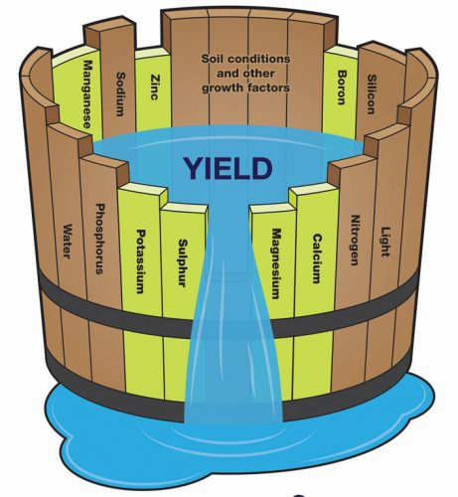

Growth Stages of Tomato Plant
Germination
Plant is not much more than a seed and has not fully developed any leaves. Germination lasts about 6-12 days.
Seedlings
Plant has penetrated past the soil and has developed two “seedling” leaves. Seedling stage lasts about 7 days.
Vegatative
Plant has developed it’s “true” leaves. These are the first leaves grown after the seedling leaves, and they are unique to the plant species.
Flowering
The first flower buds appear on the plant. It is now okay to begin pruning.
Fruiting
The first fruits appear on the plant. In a greenhouse environment an indeterminant tomato plant will continue to fruit, and its main stem will continue to grow as long as the plant is kept healthy and properly maintained. The number of days to harvest varies depending on the variety.

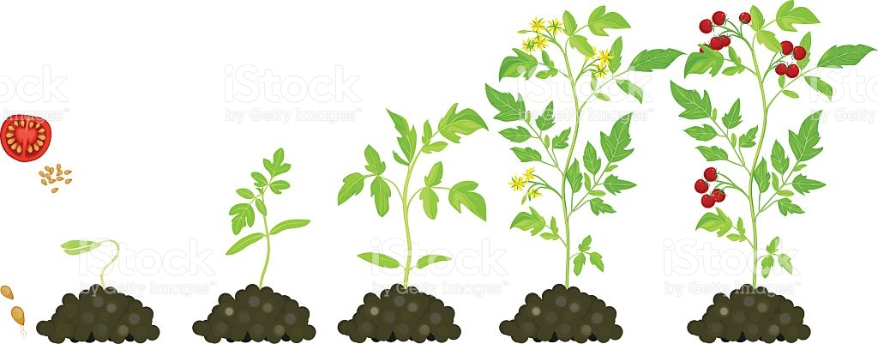

Seedling Vegatative Vegatative Flowering Fruiting
Figure 4: Growth stages of tomato plant.

How to Prune Tomatoes
When growing tomatoes, the ultimate goal is to help the plant yield as much ripe fruit as possible. If you’re growing indeterminate or “vining” varieties, pruning your plants to remove unwanted shoots and leaves ensures that all the nutrients are going to the tomatoes. If you’re growing a determinate variety, too much pruning is counterproductive. Indeterminate varieties grow like vines, and they must be trained upright and pruned in order to grow correctly. Determinate varieties contain themselves before they grow into a bush, and they naturally direct their energy toward fruiting without needing as much intervention. Here are some examples of each:
Indeterminate: Big Boy, Beef Master, Paul Robeson, Brandywine, Black Prince, German Queen, most cherry tomato varieties and most heirloom varieties.
Determinate: Ace 55, Amelia, Better Bush, Biltmore, Heatmaster, Heinz Classic, Mountain Pride and Patio.
When To Start Pruning
Check the plant for signs of yellowing. One way to know when it is time to start pruning is to wait for the stems and leaves below the first set of flowers to turn yellow. When you notice this color change, you can start pruning.
Look for flowers. It is a good idea to start pruning your tomato plants early, as soon as there are flowers on the plants. At this point, the plants should be between 12 and 18 inches. Make sure the vine-like plants are tied to supports after flowering occurs. Otherwise, the vine will grow along the ground and won’t produce healthy tomatoes.
Prune suckers regularly to keep the plant healthy. They grow quickly, so you may need to prune once or twice a week.
Identifying Suckers
Look for the tiny new branches sprouting in the crotch of the plant where a branch meets the main stem. These are called “suckers” and they’re what you want to remove. Suckers left to grow will eventually grow to the same size as the main stem, using up energy and nutrients from the rest of the plant, causing the plant to bear smaller, lower quality fruits. Strategically removing suckers will help your plant bear large fruit all season long.
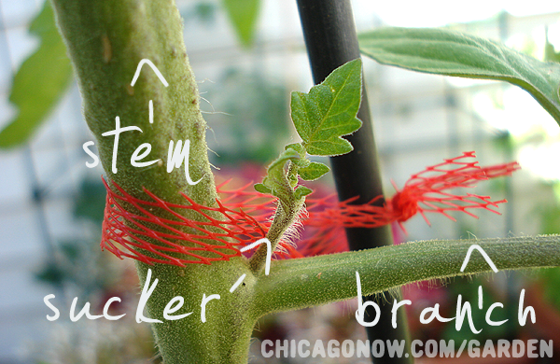
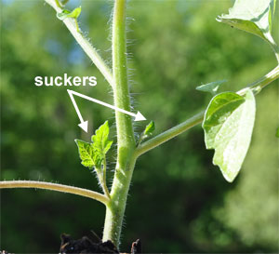

Figure 5: Examples of suckers on tomato plants.
Remove all suckers and their leaves below the first flower cluster. Do this no matter what kind of tomato plant you have. This keeps the plant strong by helping it grow a sturdy central stem. This should ensure that the majority of the nutrients are sent to the fruits, instead of being wasted on the unwanted growing tips.
As for stems and leaves, not the suckers, growing below the first flower cluster: If your plant is in a humid environment (such as a greenhouse), remove everything below the first flower cluster to improve ventilation. Humidity can make it easier for sicknesses to flourish. It also causes the wounds that are created while pruning to dry up more slowly, making the plant vulnerable for longer. By improving ventilation, you’re helping to protect the plant.
Removal Techniques
To remove a sucker, grab a growing tip by the base between the thumb and forefinger (with clean hands) and bend it back and forth until it snaps cleanly. This should ideally be done when the shoot is young and supple. The small wound will heal quickly. This is called “simple pruning”.
Leave the thicker shoots. Thicker suckers should not be snapped off, since this could damage the whole plant. If it’s thicker than a pencil, use the “Missouri pruning” method and pinch out just the tip of the sucker, leaving one or two leaves behind for photosynthesis and to protect developing fruit from sun scald. The drawback is that suckers will develop from the stem that you leave behind, which will require additional pruning. This technique is better when you’re dealing with large suckers; if the wound becomes diseased, it will be further away from the main stem. This method also leaves a few inches on the sucker to reduce the shock to the plant.
Maximizing Fruit Production
Pinch off all but four or five fruit bearing trusses for indeterminate varieties. These are the branches that grow from the main stem above the first flower cluster. Four or five will produce large, healthy fruit, but any more than that and the fruit will be small and scant. Choose four or five sturdy trusses to keep, then pinch out any additional side shoots, leaving the plant’s top shoot intact, known as the terminal shoot.
Remove yellow leaves. Yellow leaves are leaves that use up more sugar than they produce. As the plant begins to mature, the lower leaves will naturally begin to yellow and wilt. This is perfectly normal, so pull these from the plant when they appear. It will keep the plant fresh and help ward off disease.
Topping the Plant
To get the best out of the last growth of the season, it is necessary to “top” the plant. About a month before terminating the plant, remove the plant’s terminal shoot. At this point in the season, the tomatoes currently growing will have a limited time to reach maturity, so all nutrients must be directed straight to the fruit.

Disease, Pests, and Deficiencies

Chapter 2
Hydroponics System Setup

Water Cycle and Storage
Water Filtering
Water comes in from tap and gets run through a 0.2 micron filter (remove sediment), a carbon filter (remove chlorine and other charged particles), a reverse osmosis filter (remove remaining dissolved salts and solids), then UV filter (disinfect and sterilize). A water pump may be needed to aide this process. Check product information for instructions on replacing filters.
Water Storage
Filtered water is stored in a sterilized plastic bin. This is the only water to be used for any nutrient solution, humidification, media preparation, or cleaning, and the only water allowed inside the room. The storage bin is to be emptied and sterilized with hydrogen peroxide weekly.
Drain water is collected in plastic bins below the plants. Watering times should be adjusted to minimize drainage water. Drainage water is allowed to sit and evaporate unless visible buildup occurs. Drainage bins should be dried and sterilized with hydrogen peroxide weekly to prevent buildup and fungi/algae promotion.
A utility sink will be used for water waste and will have to be kept clean at all times. If it’s not possible to have a sink nearby, a reservoir will be devoted to waste water. This reservoir will be emptied daily and sterilized weekly.
Feed Line
Water is fed to plants using a timed inline pump and pressure-compensated drip feeders. Media are watered until flooded. They are then allowed to drain and sit until almost dry, at which point they are watered again. Media should never be allowed to dry completely.
The feed line will be cleaned with water weekly to prevent buildup in the line and in the growing medium. This will be done using a valve placed between the nutrient reservoir and inline pump. The rinse will have to be performed just before a feeding is about to occur so that nutrient will come in directly after. This method will prevent the plant from starving from lack of nutrients and suffocating from blocking air to the roots. If any build up is noticed on the medium or the net pot of a plant, the medium and pot can be rinsed with filtered water using a cup or bucket just before the next feeding period
Every one to two months, the feed line should be sterilized. This can be done by pumping hydrogen peroxide through the line. The hydrogen peroxide will kill the plants, so the discharge drippers will have to be removed from the plant bases so the hydrogen peroxide goes directly into the drain water bin and not through the medium.

Measuring Volumes
We will keep track of the volume in the nutrient reservoir to calculate how much nutrient a plant requires throughout the different stages of its life. It will be measured using a dipstick method. A stick devoted to this purpose will be marked out at certain lengths that denote the volume in the reservoir. The dipstick should get wiped off when done to reduce salt buildup and be sterilized when necessary.
We will keep track of total drainage volume to help us optimize feed times and reduce waste. The volume in the drainage bin will be calculated by emptying all of the drainage bins into a gallon-sized measuring cup. If there is more than one gallon of drainage, fill the measuring cup to the one gallon mark then pour it into the waste bin, then pour the remaining into the measuring cup. Keep doing this until the drainage is gone. Be sure to keep track of the volume poured out. When done measuring, all drainage gets poured down the drain.
The containers for both the humidifier and dehumidifier will be marked out with volume lines to make quick and easy measurements. The humidifier and dehumidifier numbers will be used solely to ensure proper maintenance and performance of the units.
Note: We could use these numbers to calculate plant water retention; however it is known that plants retain about 5% of water, so it may not be worth it. Due to the amount of error in our measurements and the small amount of water retained, the resulting error in our calculated retention volumes would make our number useless for future estimations. Water retention of 5% can be used for estimations if the number is ever needed.

Nutrient Solution
Making the Solution
Filtered water is measured and added to a sterile nutrient solution storage bin. The pH and EC of the water is measured and recorded. Using the “pH Up” and “pH Down” solutions, carefully adjust the water to the target pH of 5.5, following the instructions on the bottles (Table ##). Keep track of the volume of each added and record.
We will use the recommended Advanced Nutrients nutrition plan (see 7.2 Nutrition Plan for measurements). Add Part A nutrient to the water and mix. Once uniformly dissolved, add Part B and mix. Once dissolved, add the remaining nutrients one at a time and mix after each addition. It is essential that each nutrient is added one at a time and mixed well before adding the next, as they will react and create a white precipitate if mixed without being diluted. Plants cannot absorb nutrients unless they are completely dissolved in water, so if any precipitate forms the plants will not be receiving the full nutrients they need. Take a final reading of the pH and EC and record. Once mixed, turn on the air pump, circulation pump, and reservoir heater.
Note: If the pH is outside the optimal range, it will be difficult to make any adjustments due to the Advanced Nutrients “pH Perfect” technology (it uses a pH buffer which essentially holds the solution at a desired pH, and won’t change unless a large amount of acid or alkaline is added to the solution. That being said, it is still critical to get the pH of the water as close as possible to 5.5 before adding nutrients).
After making the solution it is essential to put a light-blocking lid on the reservoir to prevent the growth of algae. We will have multiple reservoir bins, so every time a reservoir is switched out it should be replaced with a clean one. The old one must then be cleaned and sterilized and stored with the lid removed to prevent mold.
Monitoring
Nutrient solution will be monitored daily for EC, pH, and temperature. None of these should really be a problem. We will use a reservoir heater to keep the nutrient solution at the desired temperature, the Advanced Nutrients diet will control our EC levels (dissolved salts), and their “pH Perfect” technology will keep our pH at 5.5 for at least a week, maybe more. Again, all of these parameters should be okay, but it’s still good to monitor them daily in the case that any issues arise.
It would be ideal if we could get a reservoir to last two weeks if not more. Monitoring all of these parameters along with visual inspection for mold/algae, salt buildup, and formation of precipitates will help determine if it is healthy to keep a reservoir for up to two weeks without exchanging solution.
pH Meter Care
The pH meter MUST be stored in the pH storage solution or else the meter will be damaged.

Temperature
Since the air temperature during the day is 70 degrees, the reservoir heater only has to be on during the nighttime hours when air temperature is dropped to 60 degrees. To keep the reservoir well insulated, we can wrap it in Styrofoam or stack it inside an empty reservoir. Reservoir temperature must be kept below 72 degrees for the solution to hold on to the dissolved oxygen.
Circulation
The nutrient will be circulated using a basic aquarium circulation pump. This will help disperse the heater from the reservoir heater, maintain a uniform solution, and prevent mold/algae growth. The pump must be mount toward the bottom of the pump so it remains underwater at all times.
Aeration
An air hose will be utilized in the reservoir to aerate the solution. Roots feed on dissolved oxygen and use it in respiration. However, too much aeration could cause damage to the plants or cause precipitates to form in the solution. If there is no precipitate after mixing, but gradually occurs throughout the week, it is most likely due to aeration. If this occurs then reduce or eliminate aeration. If precipitation continues other factors need to be investigated.

Air Quality Control
Air Quality
To ensure all target values are maintained throughout the day, a unit will be installed to read CO₂, air temperature and RH%. The unit has the capability to log all of the data it records, so we will be able analyze the atmospheric conditions throughout the span of the entire day even if we weren’t there to collect the data.
To make sure CO₂, humidity, and temperature are distributed evenly across the room, one or two oscillating fans will be utilized to stir the air. Constant air movement will also help reduce fungal attacks. Air movement must be gentle though, as too much could cause stress on the plants and more water loss through transpiration.
An air purifier will be used to help circulate air as well as remove pathogens. The purifier removes 99.97% of allergens and pollutants as small as 0.3 microns (mold spores are 10-30 microns, bacteria 0.3-60 microns) and uses UV-C radiation to disinfect the air.
Humidity
Humidity control is important for photosynthesis, transpiration, and respiration. The plants will naturally humidify the air through transpiration day and night. A dehumidifier will be utilized to reduce this and will be set to 50% RH 24 hours of the day. The tank will be measured daily and sterilized weekly. The water collected in this unit theoretically should be clean and sterile and can most likely be used again, but this remains to be determined. If not, we can pour the water down the drain.
A humidifier will be utilized to kick in if the humidity ever drops below the target RH. The unit must be filled with water that has been run through our filtration process. The humidifier will be set to 50% RH 24 hours of the day and will be sterilized on a weekly basis.
Condensation collection on leaves and other surrounding areas is a sign that humidity is too high. Flower drop is a sign air is too dry.
Air Temperature
The lights and other equipment will naturally produce heat and raise temperatures, so for the most part A/C is the only temperature control that will be needed. LED lights do not produce nearly as much heat as halides, so temperature control should be fairly easy.
A mini-split A/C and heat pump unit will be utilized to keep the room at 70 degrees during the day and 60 degrees at night. The system comes professionally hooked up with a thermostat for easy 7-day programming. The mini-split A/C requires professional installation, and is much more expensive upfront, but it is much more reliable, efficient, and safe than a portable A/C unit. It also allows for more space in the room as the unit is wall-mounted. The unit also has a heat pump in it, so we won’t have to worry about temperature control during the cooler months.

CO₂ Control
CO₂ levels in the grow room will be controlled using a CO₂ tank and a Titan CO₂ regulator. This will be automated to release CO₂ at certain intervals to keep the CO₂ level in the air between 1000-1200 PPM (see Figure 8 for regulator settings).
The CO₂ will be released through a ¼” hose woven through the roofing. Holes will be poked in the hose to allow for even distribution. CO₂ is heavier than air, causing the gas to “rain” down and distribute over the plants. We will have a unit than reads temperature, humidity, and CO₂ PPM, which we will use to take readings on all of these levels.
CO₂ is needed for photosynthesis; however it is produced by the plant during respiration. Therefore the regulator will be turned off during nighttime conditions and turned on an hour into the daytime. The Titan Controls Apollo 12 has a photocell that easily allows for this kind of operation.

Electrical and Lighting
Electrical
The circuit board will have to be rigged to have three 20A circuits supporting all of the equipment. One circuit will be for lighting, one for A/C, and one for everything else. All of the equipment will be on scheduled timer outlets (see 7.4 Equipment Information for equipment schedule).
If we tried to put everything on one circuit we run the risk of blowing a circuit which would turn everything off and kill the plants if not flipped back on. The even bigger risk is getting close to 20A and having it run for an extended period of time. This could cause the circuit cable to overheat and spark an electrical fire.
Lighting
The lights will be on timers to be on for 16 hours during the day and 8 hours at night, with nighttime centered around midnight. Lights will have to be raised and lowered throughout the plant’s lifespan to keep the light at the optimal height above the plant canopy.
For this project LED lighting is the better and safer option (see 7.6 CMH vs. LED for more details). The Optic 4 LED lights chosen have the following specifications:
- 4x 50W CREE COB LEDs
- 64x 5W supplemental LEDs (red, white and blue diodes)
- Veg: 4’ x 4’ footprint @ 24”-36” hang height
- Flower: 3.5’ x 3.5’ @ 24” hang height

Cleaning and Sterilization
Hydrogen peroxide will be used to sterilize pipes, filters, drippers, etc. Hydrogen peroxide is the best means of sterilization as it is composed of only hydrogen and oxygen and decomposes into water and oxygen gas. That being said, it is still extremely toxic to plants, so you need to be careful when using it. If for any reason hydrogen peroxide will not suffice, use a bleach solution instead (1:10 bleach to water) and be sure to rinse when done to remove the remaining bleach.
Cloth and traditional rags will be used sparingly if at all. Single-use paper towels are much more sanitary. Lint-free paper towels will be used if necessary.
A utility sink will be used for water waste and will have to be kept clean at all times. If it’s not possible to have a sink nearby, a reservoir will be devoted to waste water.
We may have to use sporekill/quatro for storage tanks to protect them from mold and bacteria, but this will be something we will have to determine as we go. If bugs and pests ever become a problem we can look into using organic pesticides or essential oils, but being a “sealed” room we should be okay.

Growing Method and Plant Care
Starting from Seed
Soak coco coir in water and drain to remove the salt from the material. Do this a few times to ensure most of the salt has been removed. With the coco coir still moist, place 2-3 seeds ¼” deep and pat down lightly. Place seeds in covered container to keep moist and let them rest in a 70-80 (77-79 optimal) degree room.
Once the seeds sprout, remove the covering and place seeds under a light source until the first “true leaf” has grown. The true leaf is larger and different in appearance than the first one or two “seed leaves” (10-14 days from planting). During this period be sure to keep the substrate moist, but do not over water, as more plants in this stage are killed by overwatering (root rot) rather than too little water.
Transfer
Carefully transfer seedlings into net pots (if not already) and add them to the hydroponic system. Plants are now in the vegetative state so be sure to follow the grow instructions outlined in 7.1 Target Values. Plants in vegetation use up less nutrients, so make sure they are not on the same schedule as more mature plants as it could drown the roots.
Maintenance
Plants will need to be trained along garden twine as they grow to support them vertically. Once the plants reach the ceiling, they will be lowered by adding slack into the twine and will be allowed to grow back to the roof. This process will be repeated until it is decided to terminate the plant.
In the garden we will designate only a portion of the plants to grow perpetually. This is so we can gather more data on the early stages of the plant life, try different diets, and experiment with different tomato varieties. Later on we may want to consider having a separate vegetative subroom, but with LED lights it may not be necessary.
Coco blocks are to be washed weekly with fresh water to prevent salt buildup. Plants must also be pruned as needed to maximize growth (see 1.3 How to Prune Tomatoes for more details).
Pollination
Naturally, wind and bees are responsible for carrying out pollination; however in the grow room, we are responsible. This can be done easily either with an electric toothbrush or by gently shaking the rope the plants are climbing. With the electric toothbrush you simply turn it on and hold it on the stem behind the flower you wish to pollenate. The vibration should be good enough to fertilize the plant.

Chapter 7
Appendix

Target Values

Table 1: Optimal Conditions for Nutrient Solution
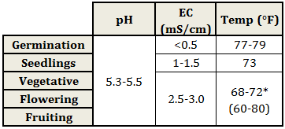
Table 2: Evaluation of pH Values for Plant Growth
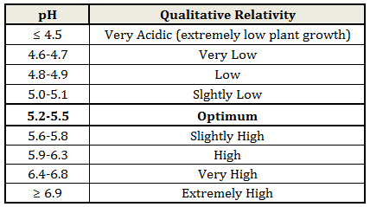
Table 3: Optimal Atmospheric Conditions
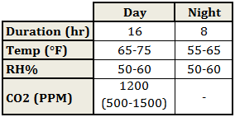

Nutrition Plan
The following concentrations are in mL/L, meaning “X” mL of nutrient for every liter of filtered water. Our maximum reservoir size will be 25 L to start. As growing continues and we collect more data, the feed times and reservoir sizes will be adjusted.

Seedlings: Advanced Nutrients recommends using Coco Grow at 1 mL/L during seedling stage.
Small Plants: Advanced Nutrients recommends using 2 mL/L.
Mature Plants: Advanced Nutrients recommends using 4 mL/L.

Table 4: Advanced Nutrients' Diet Recommendation (mL/L of water)
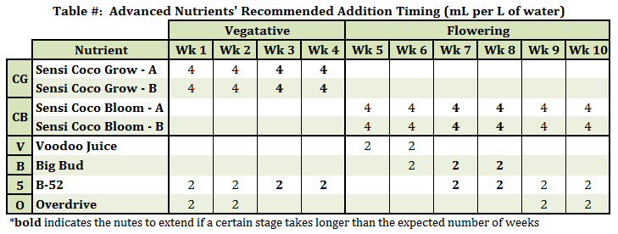

Table 5: Estimated Solution Volume Usage
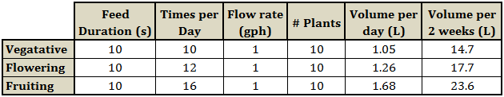

Nutrient Deficiency Symptoms

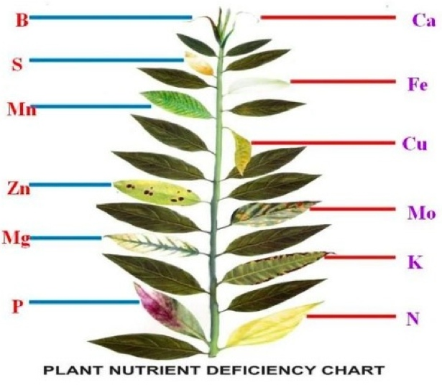

Figure 6: Visual symptoms of nutrient deficiencies.

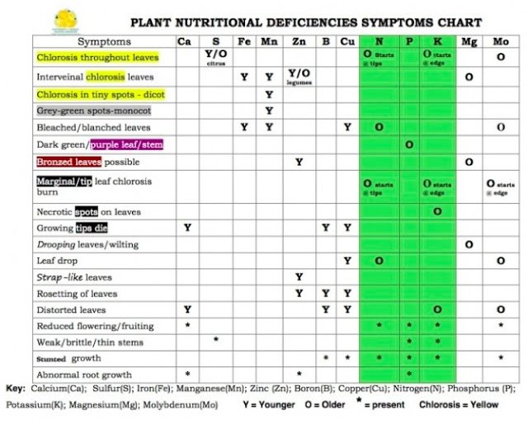

Figure 7: Plant nutrient deficiencies chart.

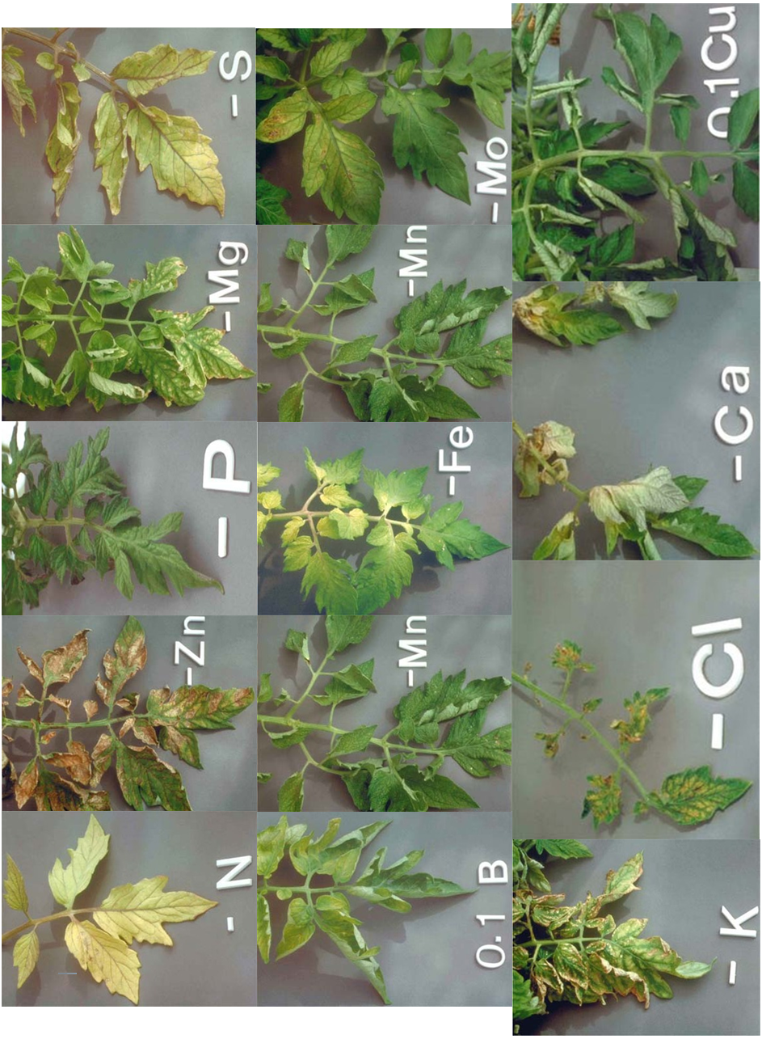



Equipment Information

Table 6: Equipment Power Source Allocation
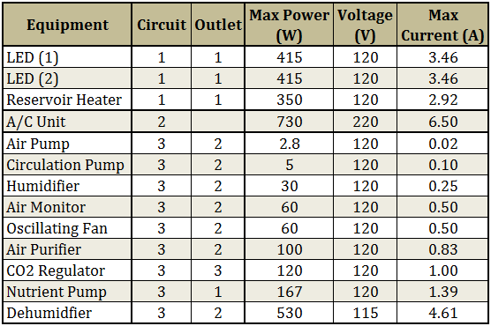

Table 7: Equipment Schedule
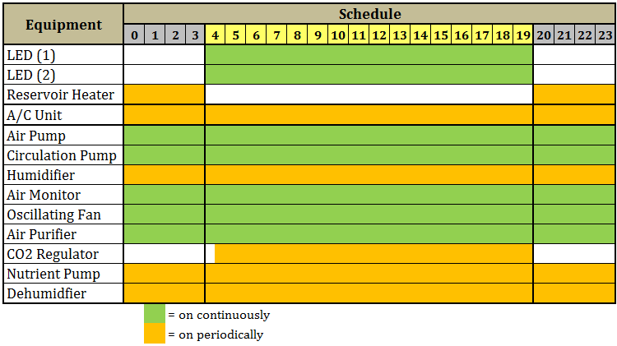

CO₂ Distribution

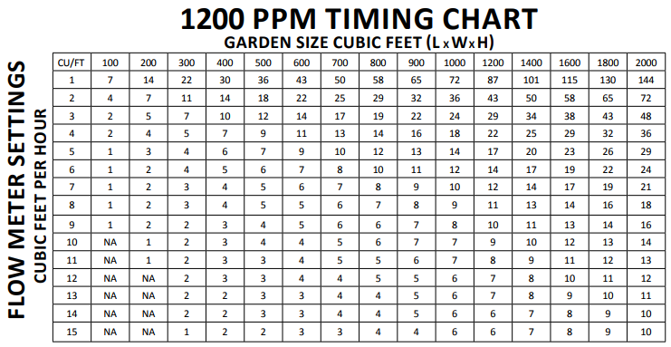

Figure 8: CO2 timing chart.

CMH vs. LED
The two best options for lighting are ceramic metal halide (CMH) and LED. CMH is good because it has low initial cost and produces a good spectrum along with UV and infrared rays. The downfall is that it produces more heat than LED, so it requires more cooling and poses a fire hazard. The bulbs also have to get replaced every year or so which adds up in the long run. Different bulbs or extra light units are required for the different stages as the vegetative stage requires blue light, while the flowering stage requires red light. These lights will require a cooling system that increases their initial cost in relation to LED that doesn’t require extra cooling. CMH lights also require a ballast that also uses up power. So a CMH light may be advertised as a 315W light, but really uses 400Wonce you consider the power usage of the ballast.
LED is more expensive upfront, but in the long run comes to be about the same if not cheaper. It is easier to implement as the light intensities of certain spectrums can be adjusted to shift red or blue, so one unit can be used for all plant stages. It is much safer as the unit doesn’t get nearly as hot, so it is much less of a fire hazard. Some units also have the capability to produce the UV and infrared light that plants like. Unlike the CMH lights, bulbs do not have to get changed and have a lifespan of up to 10 years.
The figures on the following page compare the spectrums of CMH vs. LED vs. natural sunlight on a scale relative to the max intensity in the McCree Curve (black line in the CMH figure). The McCree curve is a well-accepted representation of the spectrum plants desire.

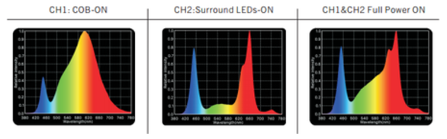

Figure 9: Optic 4 LED spectrum.
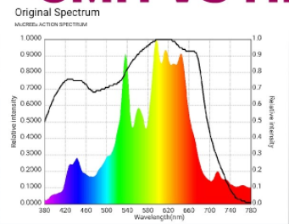

Figure 10: General CMH fixture spectrum, McCree Curve shown in black.
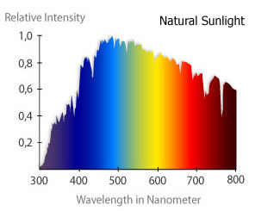

Figure 11: Spectrum of natural sunlight.

Conversions and Numbers

